View Serializability

* A schedule will view serializable if it is view equivalent to a serial schedule.
* If a schedule is conflict serializable, then it will be view serializable.
* The view serializable which does not conflict serializable contains blind writes.

View Equivalent

Two schedules S1 and S2 are said to be view equivalent if they satisfy the following conditions:

1. Initial Read

An initial read of both schedules must be the same. Suppose two schedule S1 and S2. In schedule S1, if a transaction T1 is reading the data item A, then in S2, transaction T1 should also read A.

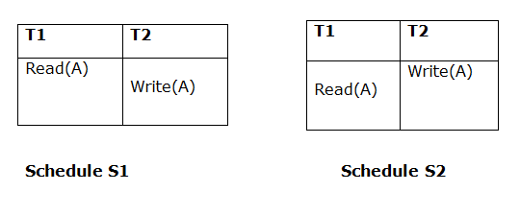

Above two schedules are view equivalent because Initial read operation in S1 is done by T1 and in S2 it is also done by T1.

2. Updated Read

In schedule S1, if Ti is reading A which is updated by Tj then in S2 also, Ti should read A which is updated by Tj.

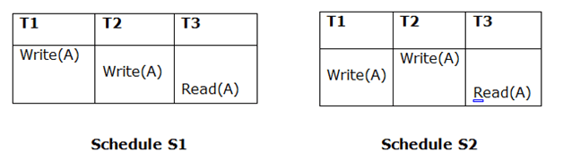

Above two schedules are not view equal because, in S1, T3 is reading A updated by T2 and in S2, T3 is reading A updated by T1.

3. Final Write

A final write must be the same between both the schedules. In schedule S1, if a transaction T1 updates A at last then in S2, final writes operations should also be done by T1.

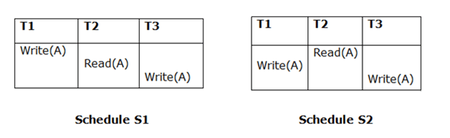

Above two schedules is view equal because Final write operation in S1 is done by T3 and in S2, the final write operation is also done by T3.